EXPERIMENT 4
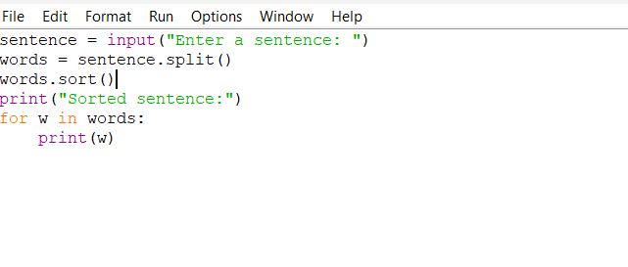
OUTPUT
